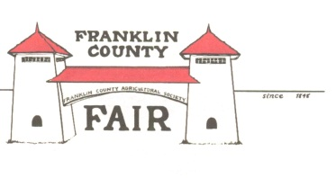

Franklin County Agricultural Society

Membership Application

Date: ______________

First Name: ___________________ Last Name: ________________________

Mailing Address: __________________________________________________

Town: _____________________ Zip Code: ______________

Home Phone: _________________________ Mobile Phone: ________________________

Email: _______________________________________________

**Welcome! Thank you for joining us. Some of our membership benefits include:**

- Free tickets to the Fair - Kid friendly meetings - Member cookouts

- Join in the decision making for the future of the Fairgrounds

- Earn community service credits for school - Free yearly t-shirt during County Fair

- Opportunities to volunteer at concerts and festivals hosted at the Fairgrounds

**Are there any areas of Fair operations that you already know you want to volunteer with?**

__ Attractions and Entertainment __ Fair Parade

__ Exhibition Halls (Youth or Roundhouse) __ Marketing

__ Fish and Wildlife __ Craft Tent

__ Cattle, Sheep, Rabbits, or Poultry __ Sponsorship

__ Children’s Activities __ Fair Parking

__ Grounds Maintenance __ Fair Tickets/Sales

*Please note all members must be able to pass a CORI/Background check. The fairgrounds are always monitored by video surveillance. The Board of Directors reserves the right to review and possibly deny any membership application. Fair membership may come with annual dues.*