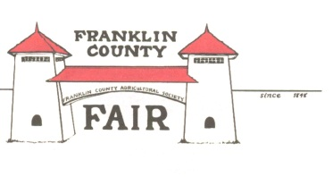
Franklin County Agricultural Society
Membership Application

Application Date: ______________
First Name: ___________________ Last Name: ________________________
Mailing Address: __________________________________________________
Town: _____________________ Zip Code: ______________
Home Phone: _________________________ Mobile Phone: ________________________
Email: _______________________________________________

Why are you interested in being a member with the Society?

What areas of Fair operations are you interested in volunteering with?
__ Attractions and Entertainment __ Fair Parade
__ Exhibition Halls (Youth or Roundhouse) __ Marketing
__ Fish and Wildlife __ Craft Tent
__ Cattle, Sheep, Rabbits, or Poultry __ Sponsorship
__ Children’s Activities __ Fair Parking
__ Grounds Maintenance __ Fair Tickets/Sales
Annual Dues $20.00. Make checks payable to FCAS.
FCAS, P.O. Box 564, Greenfield, MA 01302

